Q1.1

Pick two correspondence points $x_{1}={[\begin{matrix}0 & 0 & 1\end{matrix}]}^{T}$ in $C_{1}$ and $x_{2}={[\begin{matrix}0 & 0 & 1\end{matrix}]}^{T}$ in $C_{2}$. The fundamental matrix should satisfy:

$$x_{2}^{T}Fx_{1}=0$$

Which represents:

$$\left[\begin{matrix}0 & 0 & 1\end{matrix}\right]\left[\begin{matrix}F_{11} & F_{12} & F_{13} \\ F_{21} & F_{22} & F_{23} \\ F_{31} & F_{32} & F_{33}\end{matrix}\right]\left[\begin{matrix}0 \\ 0 \\ 1\end{matrix}\right]=\left[\begin{matrix}F_{31} & F_{32} & F_{33}\end{matrix}\right]\left[\begin{matrix}0 \\ 0 \\ 1\end{matrix}\right]=F_{33}=0$$

Q1.2

The translation matrix:

$$t=[\begin{matrix}t_{1} \\ t_{2} \\ t_{3}\end{matrix}]$$

We know that:

$$x^{'}=R(x-t)$$

Since the transformation is pure translation that is parallel to the x-axis, then we can know that:

$$t_{2}=0,t_{3}=0$$

$$R=[\begin{matrix}1 & 0 & 0 \\ 0 & 1 & 0 \\ 0 & 0 & 1\end{matrix}]$$

$$E=R[t_{×}]$$

$[t_{×}]$ is the cross-product matrix of translation matrix:

$$\left[t_{×}\right]=\left[\begin{matrix}0 & -t_{3} & t_{2} \\ t_{3} & 0 & -t_{1} \\ -t_{2} & t_{1} & 0\end{matrix}\right]=[\begin{matrix}0 & 0 & 0 \\ 0 & 0 & -t_{1} \\ 0 & t_{1} & 0\end{matrix}]$$

$$E=R\left[t_{×}\right]=\left[\begin{matrix}1 & 0 & 0 \\ 0 & 1 & 0 \\ 0 & 0 & 1\end{matrix}\right]\left[\begin{matrix}0 & 0 & 0 \\ 0 & 0 & -t_{1} \\ 0 & t_{1} & 0\end{matrix}\right]=[\begin{matrix}0 & 0 & 0 \\ 0 & 0 & -t_{1} \\ 0 & t_{1} & 0\end{matrix}]$$

$$l_{2}=Ex_{1}=\left[\begin{matrix}0 & 0 & 0 \\ 0 & 0 & -t_{1} \\ 0 & t_{1} & 0\end{matrix}\right]\left[\begin{matrix}x_{1} \\ y_{1} \\ 1\end{matrix}\right]=[\begin{matrix}0 \\ -t_{1} \\ y_{1}\end{matrix}]$$

So the epipolar line for $C_{2}$ is $-t_{1}y_{2}+y_{1}=0$, which is parallel to x-axis. So is the same reason why the epipolar line for $C_{1}$ is also parallel to the x-axis.

As a result, the epipolar lines in the two cameras are also parallel to the x-axis.

Q1.3

At different time stamps, use $x$ to represent the points in image and **X** to represents the corresponding points in the real world.

$$\left[\begin{matrix}x_{i} \\ y_{i} \\ 1\end{matrix}\right]=K\left[R_{i} | t_{i}\right]\left[\begin{matrix}\begin{matrix}X \\ Y \\ Z\end{matrix} \\ 1\end{matrix}\right]=K(R_{i}\left[\begin{matrix}X \\ Y \\ Z\end{matrix}\right]+t_{i})$$

$$\left[\begin{matrix}x_{1} \\ y_{1} \\ 1\end{matrix}\right]=K\left[R_{1} | t_{1}\right]\left[\begin{matrix}\begin{matrix}X \\ Y \\ Z\end{matrix} \\ 1\end{matrix}\right]=K(R_{1}\left[\begin{matrix}X \\ Y \\ Z\end{matrix}\right]+t_{1})$$

$$\left[\begin{matrix}x_{2} \\ y_{2} \\ 1\end{matrix}\right]=K\left[R_{2} | t_{2}\right]\left[\begin{matrix}\begin{matrix}X \\ Y \\ Z\end{matrix} \\ 1\end{matrix}\right]=K\left(R_{2}\left[\begin{matrix}X \\ Y \\ Z\end{matrix}\right]+t_{2}\right)→\left[\begin{matrix}X \\ Y \\ Z\end{matrix}\right]=(K^{-1}\left[\begin{matrix}x_{2} \\ y_{2} \\ 1\end{matrix}\right]-t_{2})∙R_{2}^{-1}$$

$$\left[\begin{matrix}x_{1} \\ y_{1} \\ 1\end{matrix}\right]=K\left(R_{1}\left[\begin{matrix}X \\ Y \\ Z\end{matrix}\right]+t_{1}\right)=K\left(R_{1}(K^{-1}\left[\begin{matrix}x_{2} \\ y_{2} \\ 1\end{matrix}\right]-t_{2})∙R_{2}^{-1}+t_{1}\right)=KR_{1}K^{-1}R_{2}^{-1}\left[\begin{matrix}x_{2} \\ y_{2} \\ 1\end{matrix}\right]-KR_{1}R_{2}^{-1}t_{2}+Kt_{1}$$

Then, we could know that:

$$R_{rel}=KR_{1}K^{-1}R_{2}^{-1}$$

$$t_{rel}=-KR_{1}R_{2}^{-1}t_{2}+Kt_{1}$$

$$E=R_{rel}\left[t_{rel ×}\right]$$

$$F=K^{-T}\left[t_{rel ×}\right]R_{rel}K^{-1}$$

Q1.4

Assume N is one of the arbitrary points in the object, the coordinate is: $N={[\begin{matrix}a & b & c\end{matrix}]}^{T}$, then we have:

$$R=I-2NN^{T}=[\begin{matrix}1-2a^{2} & -2ab & -2ac \\ -2ab & 1-2b^{2} & -2bc \\ -2ac & -2bc & 1-2c^{2}\end{matrix}]$$

$$t=k{[\begin{matrix}a & b & c\end{matrix}]}^{T}$$

$$\left[t_{×}\right]=[\begin{matrix}0 & -kc & kb \\ kc & 0 & -ka \\ -kb & ka & 0\end{matrix}]$$

$$E=\left[t_{×}\right]R=\left[\begin{matrix}0 & -kc & kb \\ kc & 0 & -ka \\ -kb & ka & 0\end{matrix}\right]\left[\begin{matrix}1-2a^{2} & -2ab & -2ac \\ -2ab & 1-2b^{2} & -2bc \\ -2ac & -2bc & 1-2c^{2}\end{matrix}\right]=[\begin{matrix}0 & -kc & kb \\ kc & 0 & -ka \\ -kb & ka & 0\end{matrix}]$$

$$F=K^{-T}EK^{-1}=K^{-T}\left(-E^{T}\right)K^{-1}=-{\left(K^{-T}EK^{-1}\right)}^{T}=-F^{T}$$

Q2.1

The recovered F:

$$F=[\begin{matrix}-1.3110e-09 & -1.3083e-07 & 0.0011 \\ -5.9213e-08 & 3.5644e-09 & -1.6503e-05 \\ -0.0011 & 3.0478e-05 & -0.0042\end{matrix}]$$

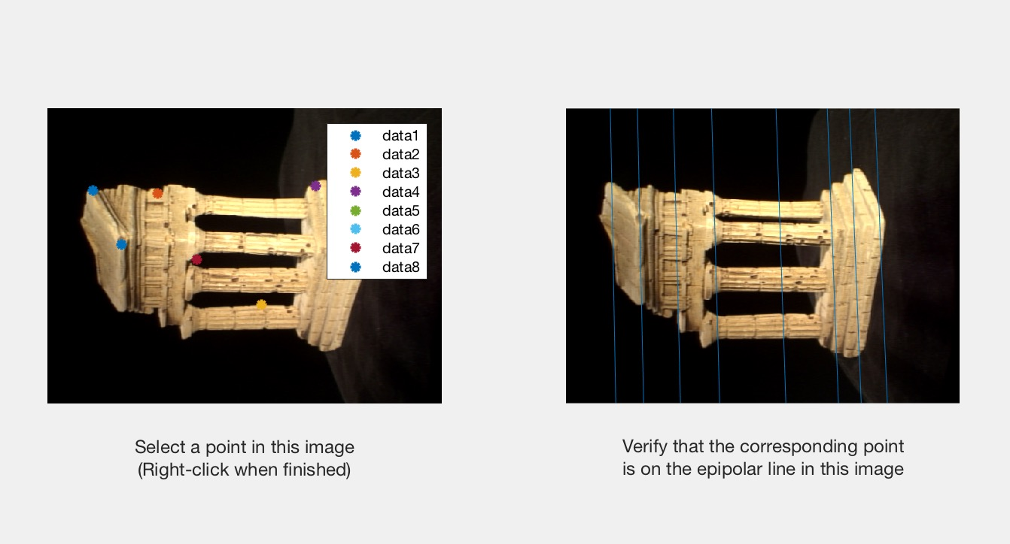

Q2.2

Seven corresponding pairs of points are selected manually. The points are saved in the ‘seven_corresp.mat’. The length of the fundamental matrix is 1, and it has been shown below:



$$F\left\{1\right\}=[\begin{matrix}-5.1637e-09 & -1.0168e-06 & 9.1795e-04 \\ 8.9601e-07 & -3.8829e-09 & -1.2952e-04 \\ -8.9282e-04 & 1.4284e-04 & -0.0022\end{matrix}]$$

Q3.1

The estimated E:

$$E=[\begin{matrix}-0.0030 & -0.3035 & 1.6603 \\ -0.1374 & 0.0083 & -0.0512 \\ -1.6651 & -0.0125 & -0.0013\end{matrix}]$$

Q3.2

$$C_{1}=[\begin{matrix}\begin{matrix}c_{11} & c_{12} \\ c_{21} & c_{22} \\ c_{31} & c_{32}\end{matrix} & \begin{matrix}c_{13} & c_{14} \\ c_{23} & c_{24} \\ c_{33} & c_{34}\end{matrix}\end{matrix}]$$

$$C_{2}=[\begin{matrix}\begin{matrix}c_{11}^{'} & c_{12}^{'} \\ c_{21}^{'} & c_{22}^{'} \\ c_{31}^{'} & c_{32}^{'}\end{matrix} & \begin{matrix}c_{13}^{'} & c_{14}^{'} \\ c_{23}^{'} & c_{24}^{'} \\ c_{33}^{'} & c_{34}^{'}\end{matrix}\end{matrix}]$$

$$A_{i}=[\begin{matrix}\begin{matrix}p_{1_x}c_{31}-c_{11} & p_{1_x}c_{32}-c_{12} \\ p_{1_y}c_{31}-c_{21} & p_{1_y}c_{32}-c_{22} \\ \begin{matrix}p_{2_x}c_{31}^{'}-c_{11}^{'} \\ p_{2_y}c_{31}^{'}-c_{21}^{'}\end{matrix} & \begin{matrix}p_{2_x}c_{32}^{'}-c_{12}^{'} \\ p_{2_y}c_{32}^{'}-c_{22}^{'}\end{matrix}\end{matrix} & \begin{matrix}p_{1_x}c_{33}-c_{13} & p_{1_x}c_{34}-c_{14} \\ p_{1_y}c_{33}-c_{23} & p_{1_y}c_{34}-c_{24} \\ \begin{matrix}p_{2_x}c_{33}^{'}-c_{13}^{'} \\ p_{2_y}c_{33}^{'}-c_{23}^{'}\end{matrix} & \begin{matrix}p_{2_x}c_{34}^{'}-c_{14}^{'} \\ p_{2_y}c_{34}^{'}-c_{24}^{'}\end{matrix}\end{matrix}\end{matrix}]$$

Q3.3

$$error=93.1082$$

$$C_{2}=[\begin{matrix}1.5197e+03 & -22.0897 & 305.1717 \\ -57.9461 & 1.4081e+03 & 635.0415 \\ 0.0013 & -0.2601 & 0.9656\end{matrix}]$$

Q4.1



Q4.2









Q5.1

I set maximum 500 iterations to find the best inliers. During each time, 7 pair of points are selected randomly to compute the F. The error metric based on the distance from point to epipolar line. The threshold is set to 0.5, if the distance between the point and the epipolar line is smaller than the threshold, that pair of points would be inliers. During each iteration, if the inliers could reach 75% of the total points, the iteration would stop.

The result of RANSAC:



The result of eight point:



Q5.3

The original 3D points:



The original M2:

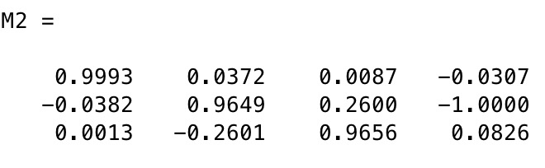

The optimized 3D points:



The optimized M2:

